CO3 ASSESSMENT TOOL 1 : Design Divide and Conquer algorithms for Merge Sort, Quick Sort, Binary Search and Matrix Multiplication (BL4, BL5)
Name: Lavanya V
Reg No: 192521271
Course Name: Design And Analysis of algorithms
Course code: CSA 0613
Linear Search in Hospital Patient Record System
Aim
To analyze the performance of Binary Search on streaming data with periodic sorting and evaluate the trade-off between sorting time and search efficiency.
Problem Statement
Streaming data continuously receives new elements, making the data unsorted over time. Binary Search requires sorted data to perform efficient searching. Analyze the execution time of both sorting and searching phases, interpret the trade-offs between preprocessing cost and search efficiency, and justify the use of Binary Search in dynamic data streams.
Algorithm
- Start the program and initialize the data stream.
- Continuously insert new elements into the dataset.
- Periodically sort the data using a sorting algorithm.
- Record the execution time required for sorting.
- Apply Binary Search to find the required element.
- Record the execution time required for searching.
- Compare sorting and searching times and display the results.

Source Code:
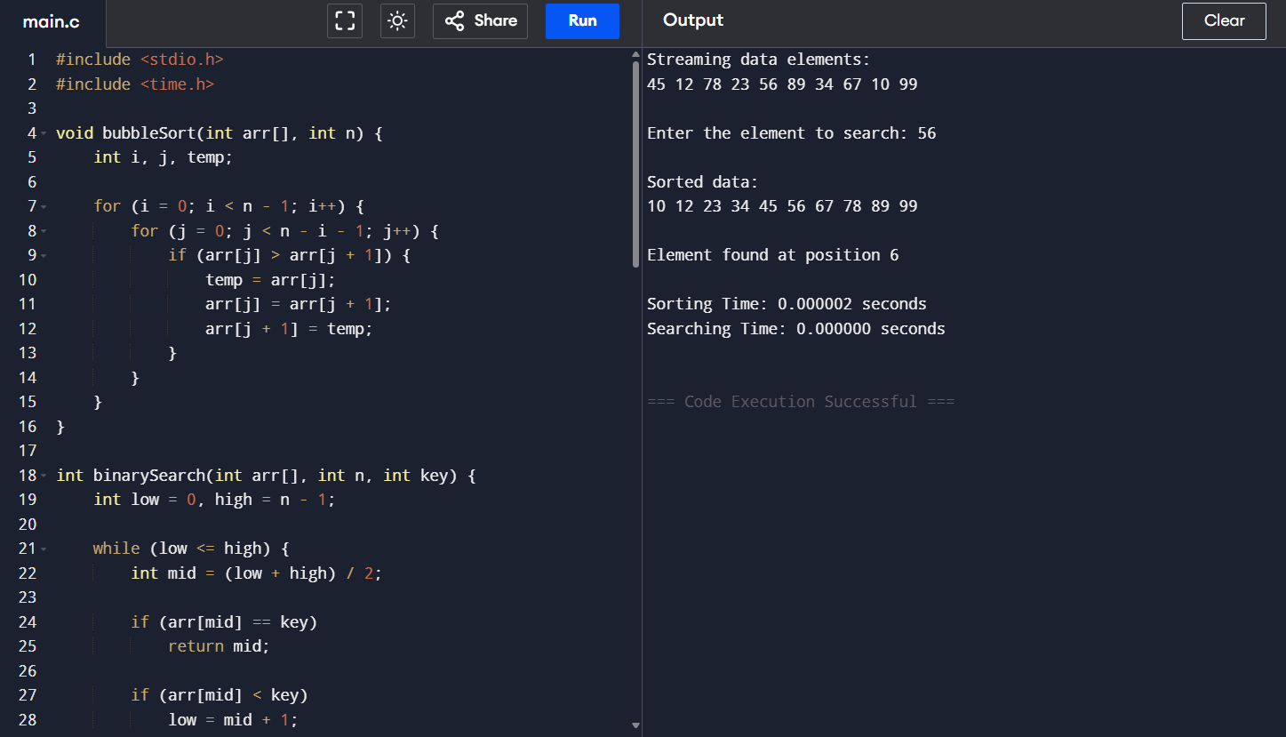
Analysis
- Sorting Time Complexity: O(n log n)
- Best Case Search Complexity: O(1)
- Average Case Search Complexity: O(log n)
- Worst Case Search Complexity: O(log n)
Binary Search performs efficiently after sorting, but periodic sorting introduces preprocessing overhead.
Documentation
- Programming Language: C
- Compiler: GCC / Code::Blocks / Dev C++
- Algorithm Used: Binary Search
- Data Structure: Array

Conclusion
Binary Search is suitable for dynamic data streams when the data is periodically sorted. Although sorting adds extra computation time, Binary Search provides fast search operations, making it efficient for applications that perform many searches on continuously updated data.

